SIMATS ENGINEERING
ASSESSMENT TOOL 2

COURSE NAME: INTERNET PROGRAMMING
COURSE CODE: CSA43
NAME: G.CHAKRADHAR
REG. NO. : 192311439

COURSE OUTCOME COVERED

CO -2 : Apply CSS layout and styling techniques to create visually appealing and responsive web interfaces, and use JavaScript to enable interactive client-side behavior. (L3)

Assessment Tool : Design Task

Weightage: 20%

QUESTIONS: Total Marks: 20

Question 1: Responsive Navigation Bar Design - Marks(4)
Suppose that an e-commerce website requires a responsive navigation bar that adapts across desktop, tablet, and mobile devices.
(a) Identify key components required in a navigation bar for an e-commerce website.
(b) Design a responsive navigation bar using appropriate CSS techniques.
(c) Demonstrate how the navigation adapts to smaller screens (e.g., hamburger menu).
(d) Evaluate the usability and suggest improvements for better user experience.

Question 2: Product Hover Effect - Marks(4)
Suppose that an e-commerce website wants to enhance user interaction through visual effects on product items.
(a) Identify suitable CSS properties for hover effects.
(b) Suggest appropriate CSS animation or transition for product interaction.
(c) Design a hover effect for a product card.
(d) Evaluate performance and user experience considerations.

Question 3: Layout Selection (Flexbox vs Grid) - Marks(4)
Suppose that a dashboard layout needs to be designed for a web application.
(a) Identify layout requirements of a dashboard (rows, columns, alignment).
(b) Compare Flexbox and Grid based on layout needs.
(c) Choose the most suitable layout technique and justify your choice.
(d) Evaluate the scalability and responsiveness of the chosen approach.

Question 4: Mobile-First Blog Layout - Marks(4)
Suppose that a blog page must be designed following a mobile-first approach.
(a) Identify key sections of a blog layout.
(b) Design a mobile-first layout using CSS.
(c) Demonstrate how the layout scales for larger screens using media queries.
(d) Evaluate accessibility and readability of the design.

Question 5: JavaScript Event Handling for Dynamic Menu - Marks(4)
Suppose that a website includes a dynamic menu that responds to user interactions.
(a) Identify appropriate JavaScript events for menu interaction.
(b) Design event handling logic for menu toggle functionality.
(c) Implement interaction for user actions (click/hover).
(d) Evaluate performance and suggest improvements.

Code of Conduct:

I G.CHAKRADHAR(192311439) certify that this submission is my original work and that I have adhered to the guidelines specified for this assessment. I understand that any violation of academic integrity rules will result in disciplinary action.

Signature of the student: S

RUBRICS FOR CALCULATION:

Criteria | Weightage (%) | Level 4 – Exemplary (4) | Level 3 – Proficient (3) | Level 2 – Developing (2) | Level 1 – Beginning (1)
Understanding of Concept | 25 | Demonstrates complete understanding of design requirements and concepts | Good understanding with minor gaps | Basic understanding with some errors | Poor understanding or incorrect concepts
Design / Implementation | 30 | Well-structured, efficient, and responsive design implementation | Correct implementation with minor issues | Basic implementation with inconsistencies | Incorrect or incomplete implementation
Use of Tools (CSS/JS) | 20 | Effective and advanced use of tools/techniques | Appropriate use of tools | Limited or inconsistent use | Incorrect or minimal use
Analysis & Evaluation | 15 | Insightful analysis with strong justification and optimization | Good analysis with justification | Basic analysis with limited depth | Poor or no analysis
Documentation / Clarity | 10 | Clear, well-structured, and properly presented solution | Mostly clear with minor issues | Basic clarity, missing details | Poor or unclear documentation

ANSWERS

Question 1

Responsive Navigation Bar Design

Key Components of an E-commerce Navigation Bar
A responsive e-commerce navigation bar should contain:
- Company Logo
- Home
- Categories/Products
- Search Bar
- Cart Icon
- Wishlist
- User Login/Profile
- Contact Us
- Hamburger Menu (for mobile devices)

Navigation Bar Layout

Desktop View

+--------------------------------------------------------------------------------+
| LOGO | Home | Products | Categories | Search | Cart | Wishlist | Login |
+--------------------------------------------------------------------------------+

Tablet View

+-------------------------------------------------------------+
| LOGO | Home | Products | Search | Cart | Login |
+-------------------------------------------------------------+

Mobile View

+------------------------------+
| LOGO ☰ Menu |
+------------------------------+
When ☰ is clicked
+------------------+
| Home |
| Products |
| Categories |
| Search |
| Cart |
| Wishlist |
| Login |
| Contact |
+------------------+

CSS Techniques Used
- Flexbox
- Media Queries
- Responsive Width
- Box Model
- Hover Effects
- Mobile-first approach

Responsive Navigation (Hamburger Menu)

Desktop
LOGO Home Products Categories Cart Login

Mobile

LOGO ☰

After Clicking ☰
Home
Products
Categories
Cart
Wishlist
Login
Contact

(d) Evaluation & Improvements
Advantages
- Easy navigation
- Mobile friendly
- Fast access to products
- Better user experience
- Supports different screen sizes

Improvements
- Add sticky navigation bar.
- Include search suggestions.
- Use icons with menu items.
- Add smooth animations for the hamburger menu.
- Highlight the active page.
- Ensure buttons are large enough for touch interaction.
- Optimize loading speed by minimizing CSS and JavaScript.

Conclusion
A responsive navigation bar built with HTML, CSS Flexbox, and Media Queries ensures that the e-commerce website works efficiently on desktop, tablet, and mobile devices. The hamburger menu improves usability on small screens, while responsive design techniques provide a consistent and user-friendly experience across all devices.

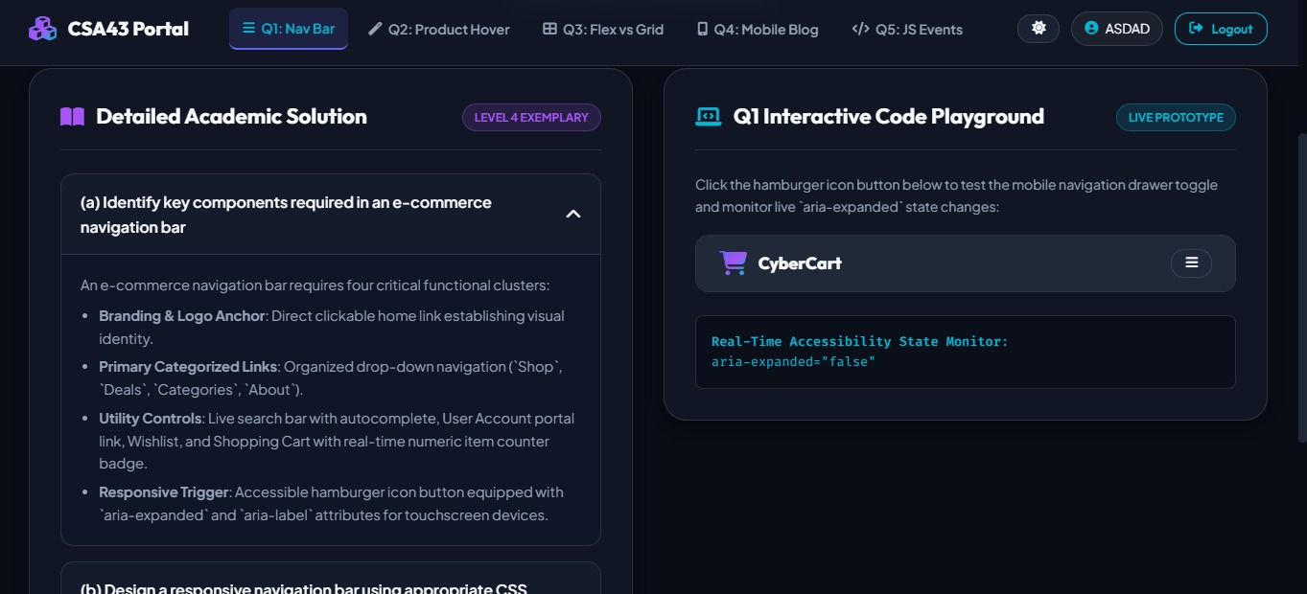

Question 2

Product Hover Effect

Suitable CSS Properties for Hover Effects
The following CSS properties create attractive hover effects:
- transform
- transition
- box-shadow
- opacity
- background-color
- color
- cursor

CSS Animation / Transition

.product{
width:250px;
border:1px solid #ccc;
padding:15px;
text-align:center;
transition:0.4s ease;
}
.product:hover{
transform:scale(1.05);
box-shadow:0 8px 20px rgba(0,0,0,0.3);
}
Product Card Design

HTML

<div class="product">
<img src="shoe.jpg" width="200">
<h3>Sports Shoes</h3>
<p>$50</p>
<button>Buy Now</button>
</div>

Layout

+----------------------+
| Product Image |
| |
| Sports Shoes |
| $50 |
| [ Buy Now ] |
+----------------------+

Hover

✔ Card enlarges
✔ Shadow appears
✔ Smooth animation

Evaluation
Advantages
- Improves product visibility.
- Attracts user attention.
- Gives interactive feedback.
- Enhances shopping experience.
Improvements
- Use smooth transitions.
- Avoid excessive animations.
- Optimize images.
- Keep hover effects lightweight.
- Ensure accessibility for keyboard users.

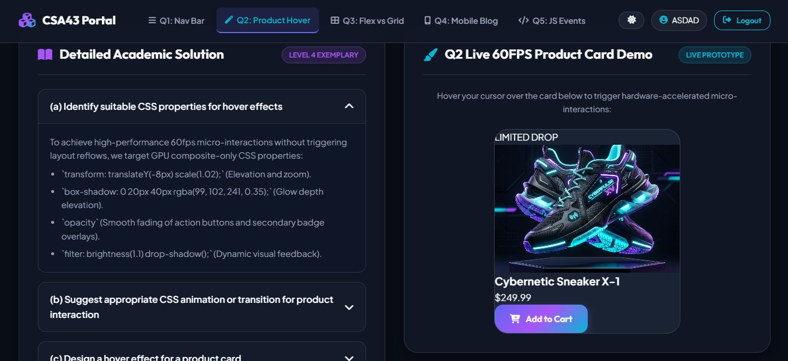

Question 3

Layout Selection (Flexbox vs Grid)

Dashboard Layout Requirements
A dashboard requires:
- Header
- Sidebar
- Main Content
- Widgets
- Footer
- Proper row and column alignment

Dashboard Layout

+---------------------------------------------+
| HEADER |
+---------------------------------------------+
| Sidebar | Dashboard | Statistics | Reports |
| | Widget 1 | Widget 2 | Widget 3 |
+---------------------------------------------+
| FOOTER |
+---------------------------------------------+

Flexbox vs Grid

Feature | Flexbox | Grid
Layout | One-dimensional | Two-dimensional
Direction | Row or Column | Rows and Columns
Best For | Navigation bars | Complete dashboards
Alignment | Easy | Advanced
Complexity | Simple | Complex

Most Suitable Technique
CSS Grid is the best choice because:
- Controls both rows and columns.
- Easy to create dashboard layouts.
- Supports responsive design.
- Organizes widgets efficiently.
Example:
.dashboard{
display:grid;
grid-template-columns:250px 1fr 1fr;
gap:20px;
}

Evaluation
Advantages
- Highly scalable.
- Responsive on all devices.
- Easy maintenance.
- Efficient space utilization.
Improvements
- Combine Grid with Flexbox.
- Add media queries.
- Optimize widget sizes.
- Use auto-fit and minmax().
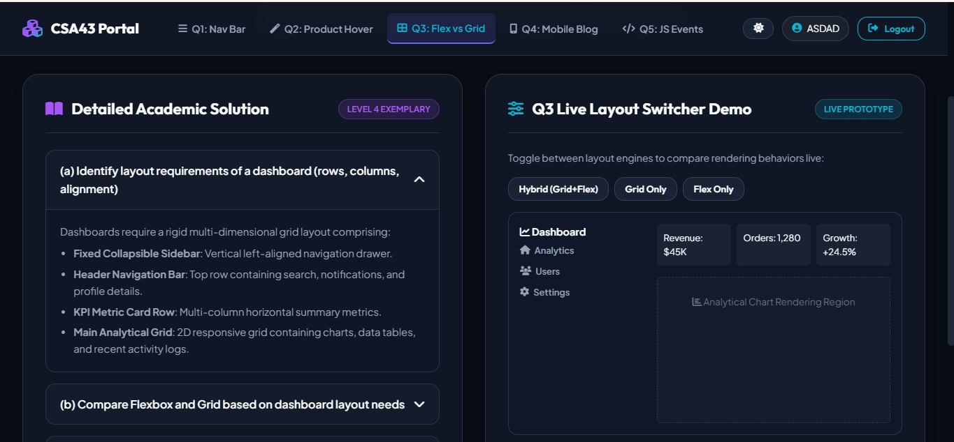

Question 4

Mobile-First Blog Layout

Key Sections
- Header
- Navigation
- Featured Image
- Blog Content
- Sidebar
- Comments
- Footer

Layout

Mobile
+------------------+
| Header |
+------------------+
| Navigation |
+------------------+
| Blog Image |
+------------------+
| Blog Content |
+------------------+
| Sidebar |
+------------------+
| Footer |
+------------------+
Desktop

+--------------------------------------------------+
| Header |
+--------------------------------------------------+
| Navigation |
+--------------------------------------------------+
| Blog Content | Sidebar |
| | |
+--------------------------------------------------+
| Footer |
+--------------------------------------------------+
CSS Design

.container{
display:flex;
flex-direction:column;
}
@media(min-width:768px){
.container{
flex-direction:row;
}
}

Media Query

@media(min-width:992px){
.sidebar{
width:30%;
}
.content{
width:70%;
}
}

Evaluation
Advantages
- Mobile-friendly.
- Better readability.
- Faster loading.
- Responsive design.
Improvements
- Use larger fonts.
- Increase spacing.
- Optimize images.
- Add dark mode.
- Ensure keyboard accessibility.

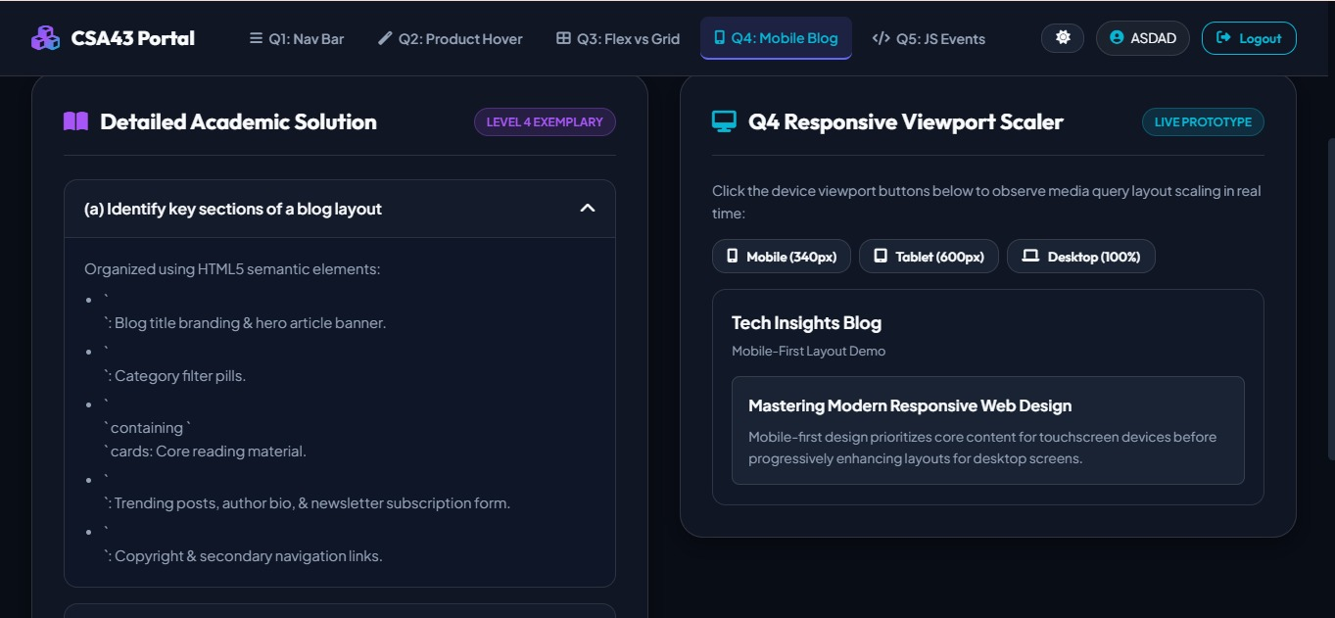

Question 5

JavaScript Event Handling for Dynamic Menu

JavaScript Events
Common events:
- onclick
- onmouseover
- onmouseout
- onmouseenter
- onmouseleave

Event Handling Logic

Flow:

User Clicks ☰
│
▼
JavaScript Function Executes
│
▼
Menu Opens / Closes
│
▼
Navigation Display Updated

Menu Toggle Implementation

HTML

<button onclick="toggleMenu()">☰</button>
<ul id="menu">
<li>Home</li>
<li>Products</li>
<li>About</li>
<li>Contact</li>
</ul>

CSS

#menu{
display:none;
}

JavaScript

function toggleMenu(){
let menu=document.getElementById("menu");
if(menu.style.display=="block")
menu.style.display="none";
else
menu.style.display="block";
}

Evaluation
Advantages
- Fast interaction.
- Easy navigation.
- Suitable for mobile devices.
- Reduces screen clutter.
Improvements
- Use CSS transitions for smoother animation.
- Debounce rapid clicks.
- Add keyboard navigation support.
- Optimize JavaScript performance.
- Improve accessibility with ARIA attributes.

